December 28, 2021

Mr. Chris Beale, AICP
Senior Planner
333 South Meridian Street, 2nd Floor
Puyallup, WA 98371

Re: Bell Property 204 4th St SW, Puyallup, WA 98371
Parcel Numbers 5745001631, 5745001632 and 5745001641
(AGC Job # 3256)

Dear Mr. Beale,
We are under contract to purchase the Bell Property. We have until January 31, 2022 to finish our feasibility study and remove our contingencies. We would like to schedule a ZOOM meeting with staff to discuss items that will impact the development of the site as soon as practical.
We have talked with Ken Cook on a number of issues and he has been very helpful. We have also discussed the site with Meridith Neal.
The subject site is zoned RM-CORE. It is in the Planned Action Area covered by Ordinance No. 3173.
It is also subject to the City of Puyallup Downtown Design Guidelines.
As you know these various codes, Ordinances and Guidelines have conflicting requirements.
The site is currently improved with a single family house. There are existing 8 foot sidewalks on the south and east side of the property.
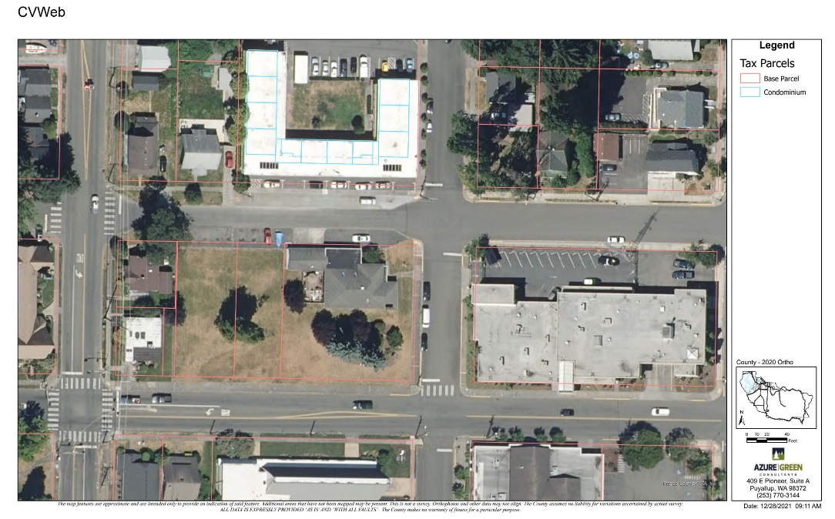
The building located at 210 5th ST SW is owned by the Christ Episcopal Church. The building just south of that is currently occupied by a tattoo business.
Across 4th St to the east is the existing City of Puyallup Police Station.
South of the site across Pioneer is the Presbyterian Church.
The zoning of the existing Police Station is Public Facilities. If the bond issue passes and the City wants to surplus this property it should be rezoned and added to the MFTE along with the Bell Property.
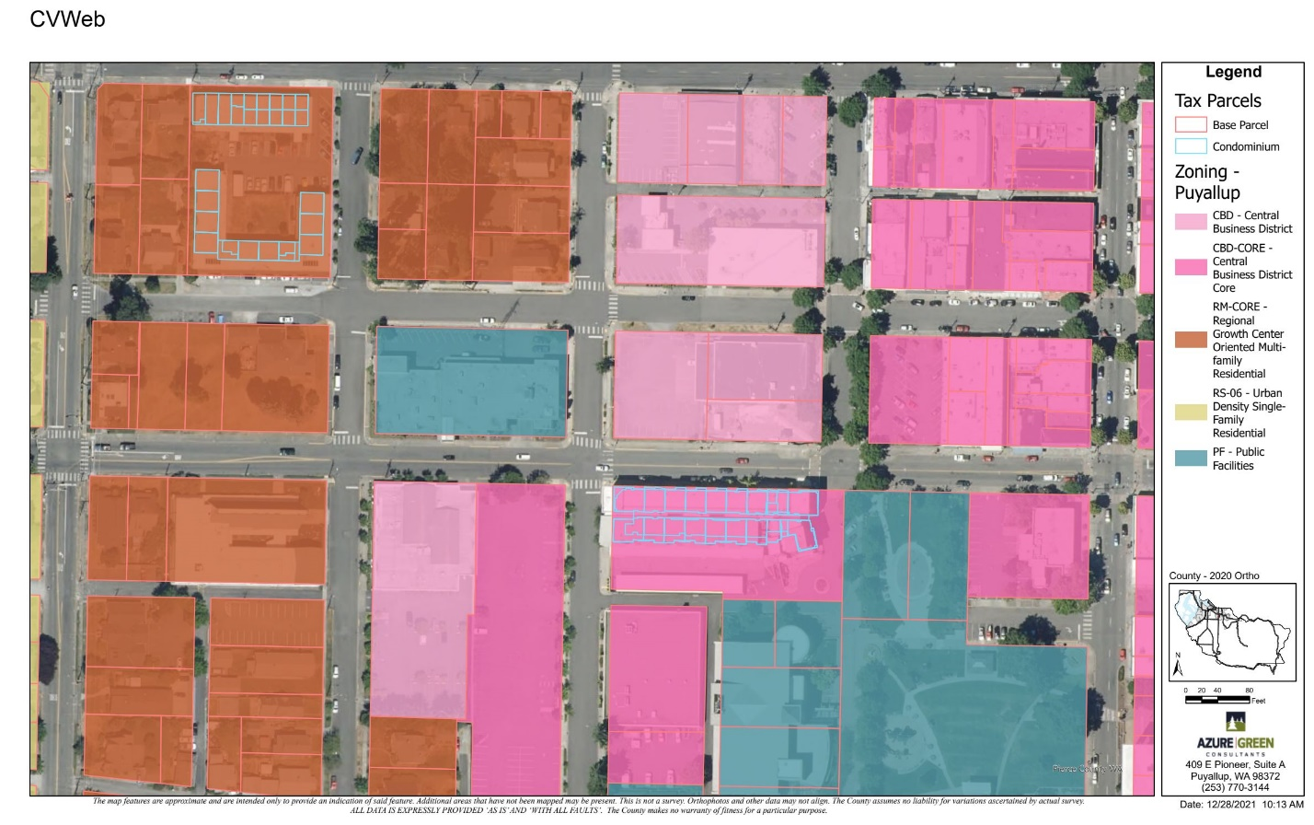
It is our understanding that the setbacks for the Bell property are as follows:
Rear yard setback 0 feet
Interior side yard setback 0 feet
Front yard setback 5 feet per 20.25.0215 Front yard and side-street setback in RM-Core zone and RM-20 zone when in downtown planned action area
Maximum Height is 50 feet with bonus height allowed per PMC 20.25.0205
20.25.0205 RM zones menu options to achieve bonus height.
In projects where one of the following features are selected, the height limitation established in PMC 20.25.020(8) may be exceeded as follows. Bonus height shall not be allowed for the portion of a building located within 100 feet of an RS single-family zone district.
(1) Five-foot increase when parking is located under the building utilizing a minimum of 60 percent of the building footprint area; or
(2) Ten-foot increase when parking is underground utilizing a minimum of 60 percent of the building footprint area. (Ord. 3172 § 1, 2018; Ord. 2694 § 1, 2001).
Our current proposed plans include a 55-foot height with all parking located under the building. We may locate the parking slightly underground to allow for a 60-foot height. It should be noted that an RS zone exists 120 feet west of the subject site.
Proposed floor to floor heights
First Floor 12 feet
Second Floor 9.5 feet
Third Floor 9.5 feet
Fourth Floor 9.5 feet
Fifth Floor 14.5 feet
Total Height 55 feet

We would like to incorporate building features including masonry columns that go 2 feet into the 5 foot front yard setback and 8 foot awnings that go 3 feet into the right of way. The current design allows for 15.5 feet of separation from the face of curb to the wall surrounding the parking structure and 13.5 feet to the masonry columns.
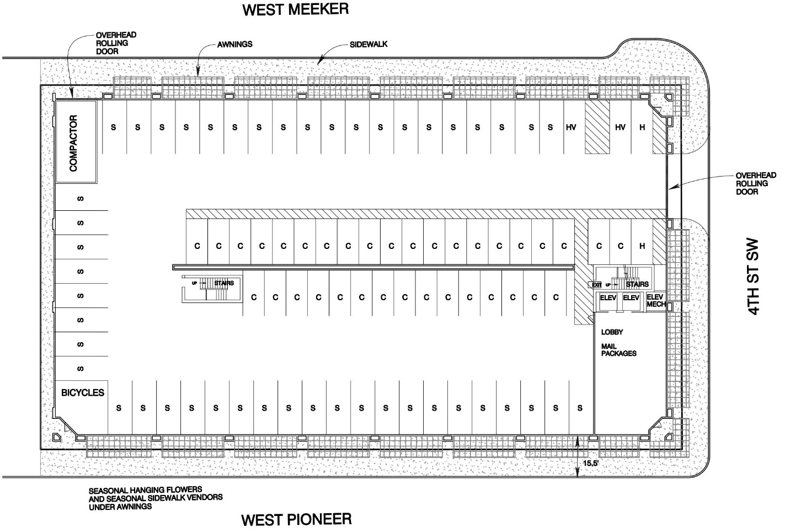
The north side of the site on West Meeker currently has 90-degree parking in the right of way and no sidewalk. We are proposing to add parallel parking with a bulb out at the corner of 4th St SW and West Meeker. We will have the same 15 feet plus of sidewalk and paved plaza between the building and the new face of curb. We are proposing to have a 5-foot pedestrian path along the west side of the building.
The illustration below shows the awnings and proposed frontage improvements.
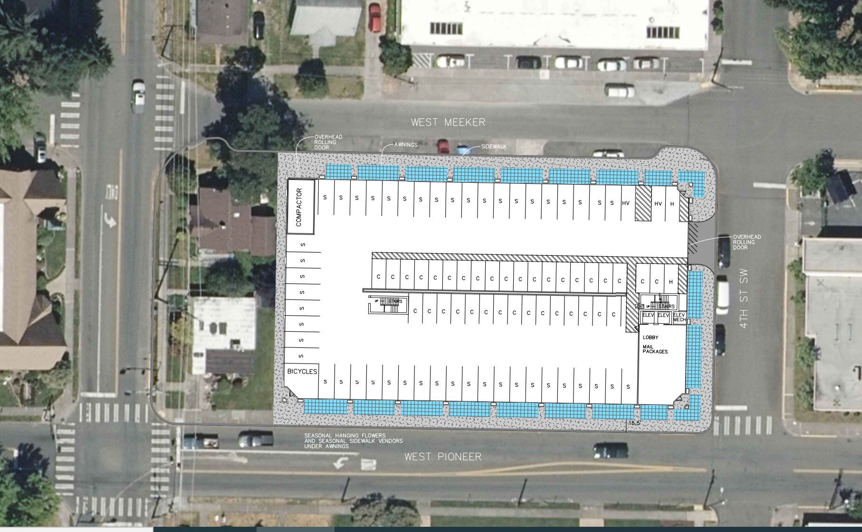

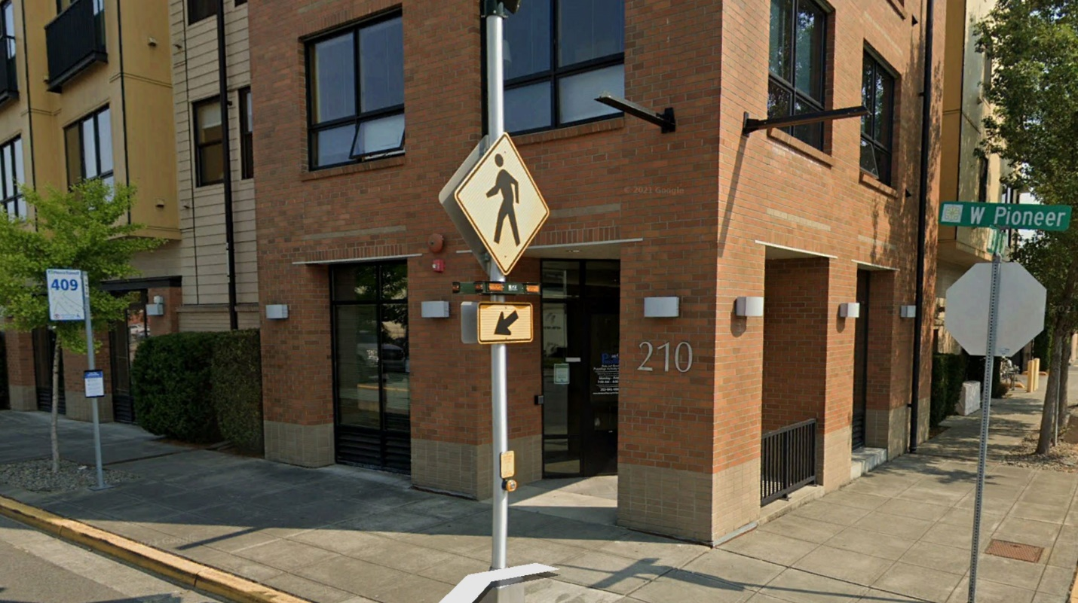
The SW, SE and NE corners of the building will have recessed entries similar to what is shown above at 210 West Pioneer. The masonry columns at 210 West Pioneer are at Zero setback from the right of way and the 2-foot projections at the upper levels are into the right of way.. . We are proposing 5 foot setback to our building and 3 foot setback to the masonry columns. This will provide for a more significant pedestrian plaza along the building than what exists at 210 West Pioneer.
The proposed second floor will be set back a minimum of 5 feet from the property line with some of the decks extending to the right of way line. There will be a large common area facility surrounded by a common terrace.
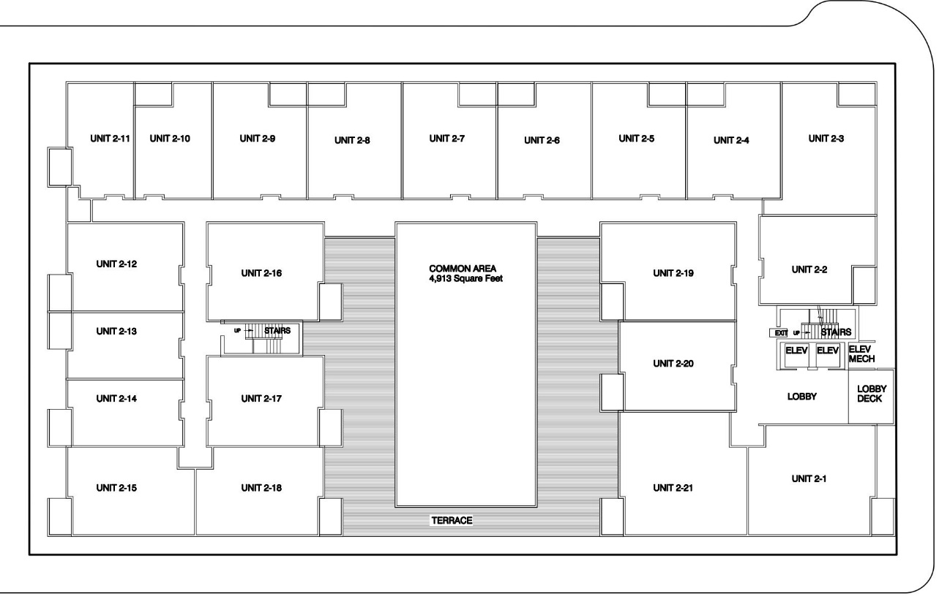
The third and fourth floors will look like this.
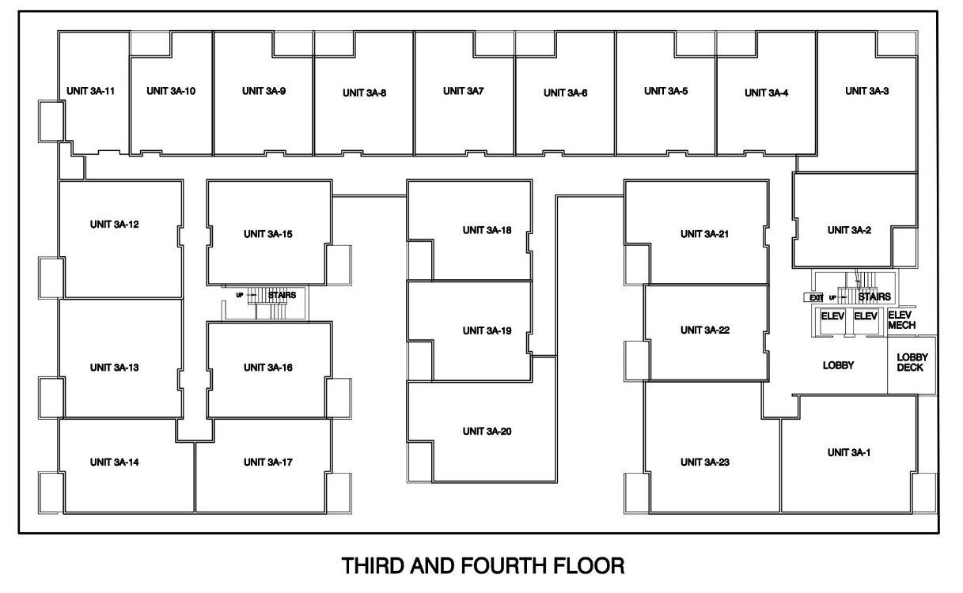
The top floor will look like this
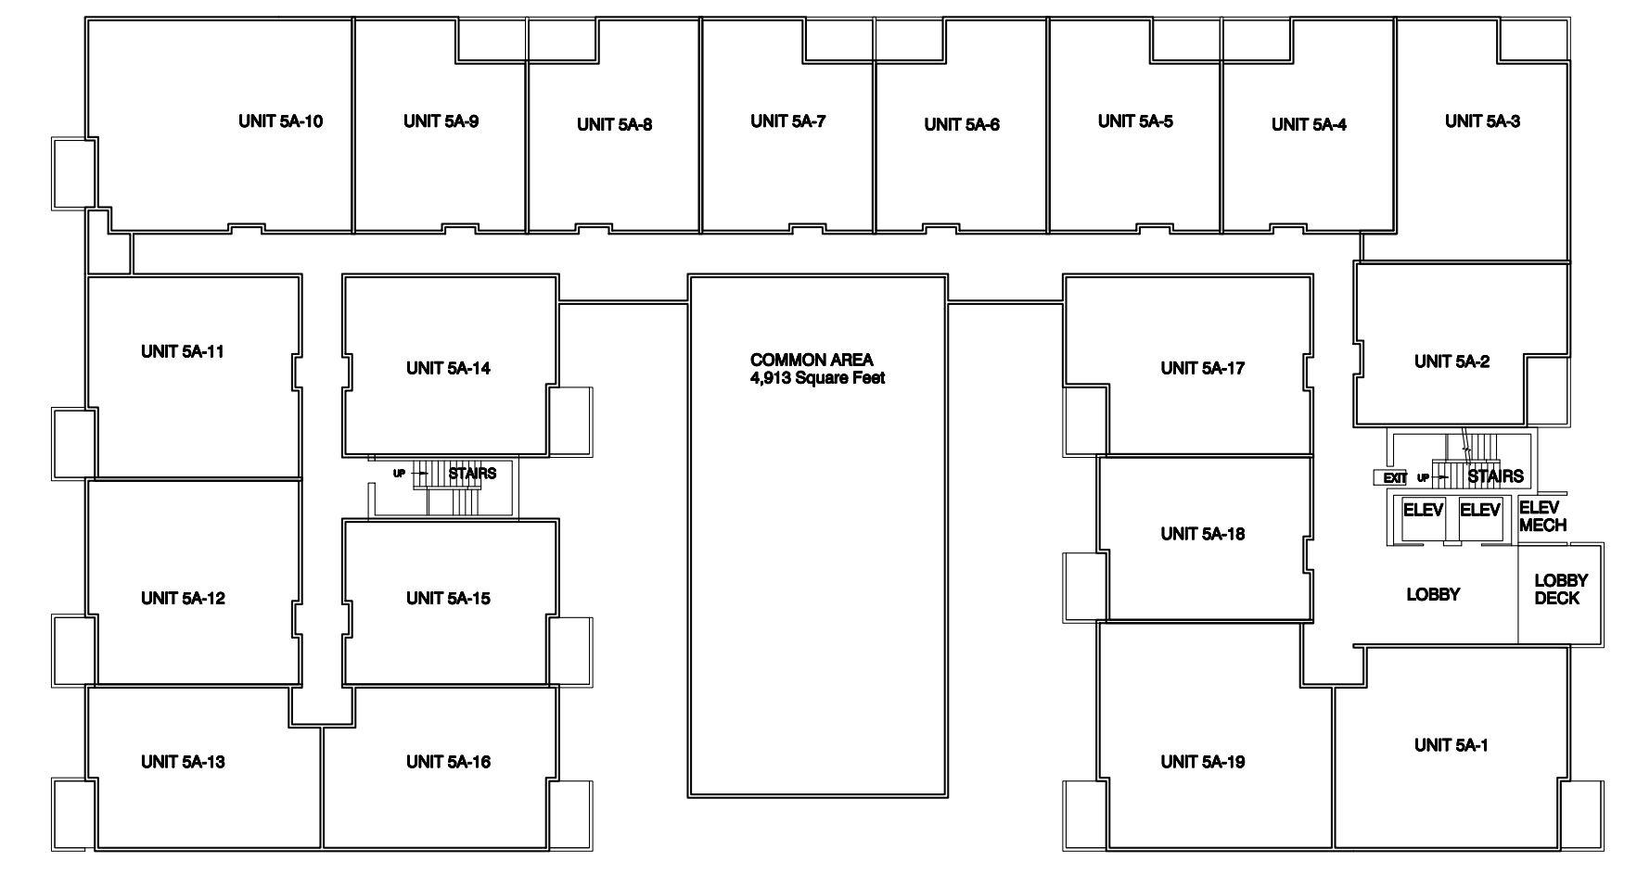
The current plan has 86 total units with a variety of floor plans and the following average square footages:
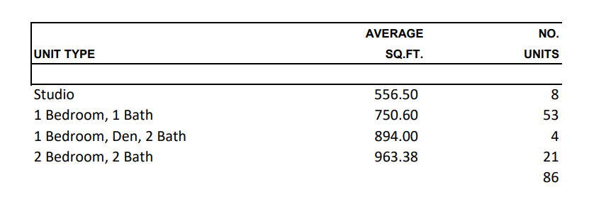
The finished project may look somewhat similar to the 6th and Alder project in Tacoma.
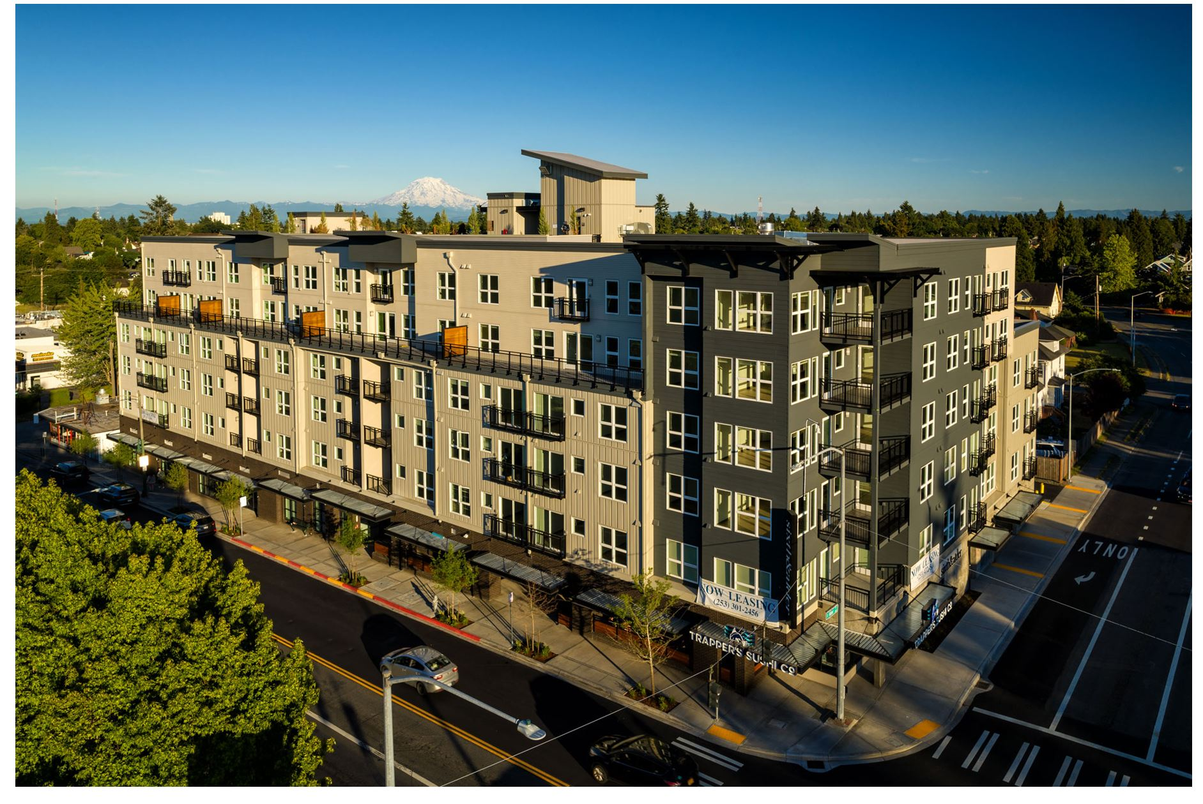
It should be noted that the Downtown Puyallup Planned Action Mitigation Document indicates that the proposed site will be able to directly discharge its storm runoff to the existing storm system. There is a 15-inch PVC storm pipe in 5th St SW that the storm flows will discharge to. Below is an excerpt from the document.
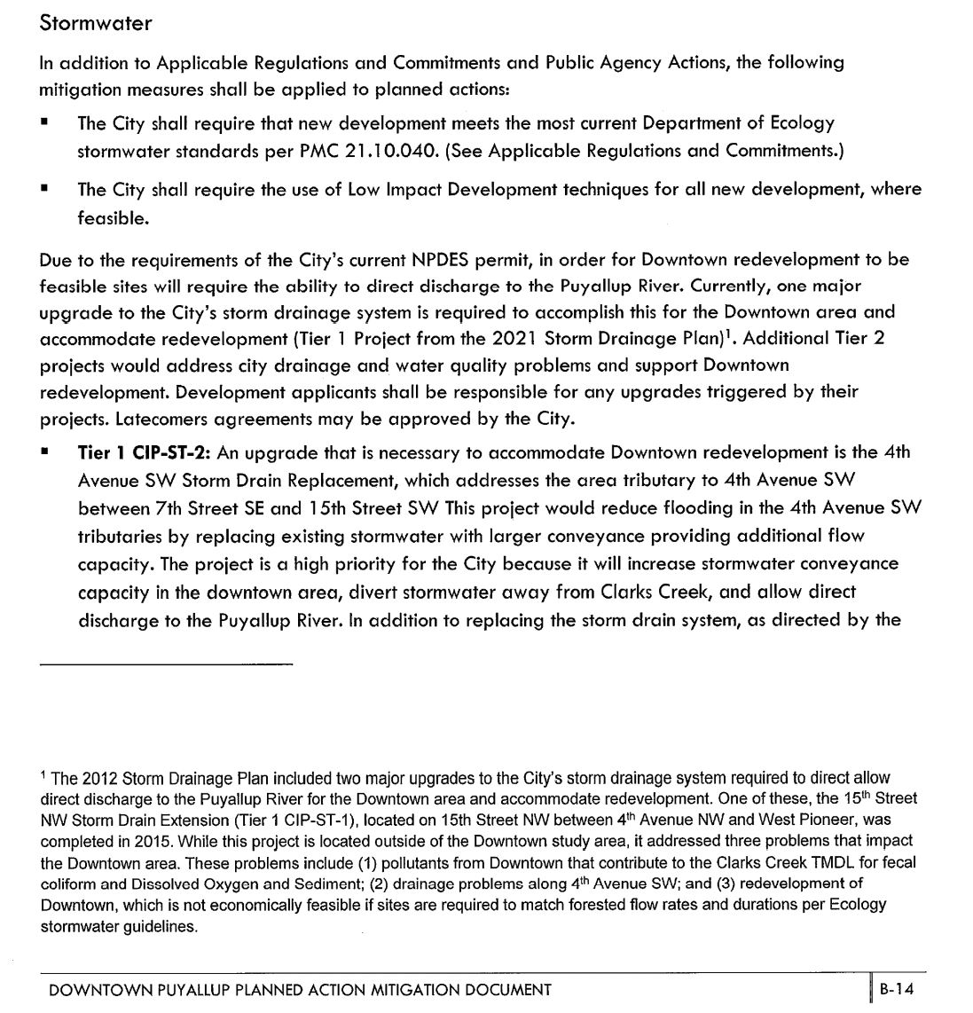

Let us know what we need to submit to get the fire flow model done through the City for the site. We understand that there will be a $400 cost for the model.
If you need further information to schedule a Zoom meeting please let us know.
Sincerely,

Paul E. Green
Paul E. Green, P.E.
Director of Planning and Engineering

